# Requirements for becoming Life Member

**Any person seeking to become Life Member/Member should satisfy the following criteria.**

1. **Age: He shall have attained the age of twenty-five years on the date of his application for election or transfer.**
2. **Minimum Qualification: Graduate in Engineering or Post graduate in Science**
3. **Occupation: He shall have been engaged in a position of responsibility in the design or execution or operation in the field of Engineering/Science or engaged in teaching in the field of Science/Engineering.**

1. **Experience: He shall have had further at least one-year professional engineering experience in a position of responsibility or teaching in relevant field.**
2. **Those members paying the life membership fee shall be considered as Life Members.**
3. **Current Life Membership fee is Rs 4000 /-. Membership fee can**

**be paid through cheque in favour of “ISSE Pune Chapter” or through bank transfer to:**

**Panjab National Bank, Pashan branch**

**Account no: 0495002100015197**

**IFSC: PUNB0049500**

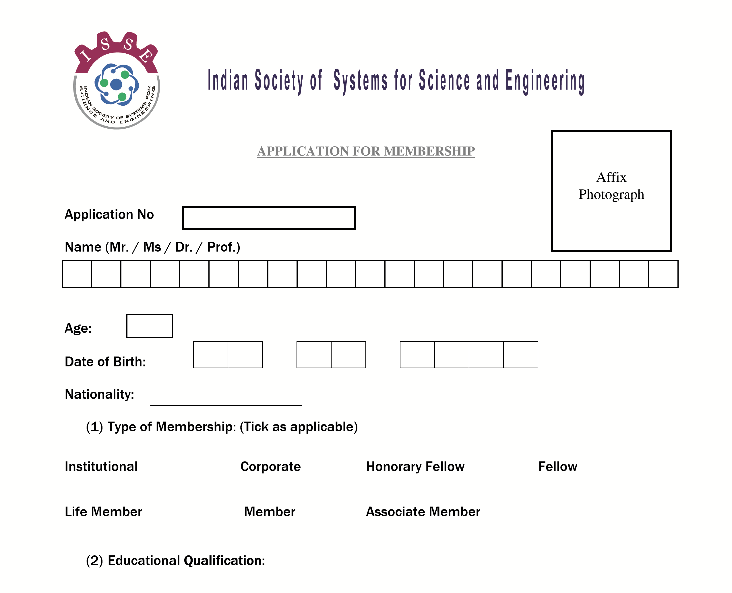



Occupation:

**(3)**

**Field of**

**Exper**

**Ience [Tick appropriate column(s)]**

Design

Execution



Operation



Teaching





Experience

(

latest first)

Organisation

period

Position held

Responsibilities/Area

1

2

3

Yes/No

:

Would like to volunteer in technical

upgradation/training programme

If Yes, Field of Expertise:

List of publication/ Technical lectures/Achievement: If required attach additional sheets

(4)

**Contact details**

**(tick preferred address/mail ID)**

|  |  |  |
| --- | --- | --- |
|  | **Official** | **Personal** |
| **Mailing address** |  |  |
| **Phone** |  |  |
| **e-mail** |  |  |
| **Mobile number** |  | |



**(5)**

**Membership fee: (Tick appropriate column)**

Rs. 10,000/-

* †

Rs. 4,000/- 

Rs. 750/-



Rs. 300/- 

Mode of payment

. Demand Draft

1

No………. ……………………Bank………………..……………………Date.………………

. Cheque

2

No………..……………………Bank………….………...…….………...Date.…………….…

. Net transfer

3

No………..……………………Bank………….………...…….………...Date.…………….…

4

. Cash

Membership of other professional bodies:

Were you at any time past member of the society? If yes, indicate period:

**Associating chapter:**

**DECLARATION**

**The personal data given above is correct to the best of my knowledge and belief. If admitted as a**

**member I undertake to be governed by the rules, regulations and byelaws of ISSE as they stand at**

**present or hereafter may be legally altered.**

**Signature**

**Place:**

**Date:**

**Recommended by:**

**Name:**

**ISSE membership no:**

**ISSE Member)**

(

**Mobile no:**

**Date:**

**Name:**

**Forwarded by:**

**Executive committee**

**Designation:**

(

**Chapter:**

**Member-local chapter/**

**National committee) Mobile no:**

**Date:**



(

**FOR OFFICE USE ONLY**

)

**Recommendation of membership committee**

**Member 1**

**Member 3**

**Member 2**

**Date:**

**Recommendation of Executive committee**

**Secretary**

**Treasurer**

**President/Vice president**

**Date:**

___________________________________________________________________________________

**Type of membership allotted:**

**Institutional**

**Corporate**

**Fellow**

**Life Member**

**If Member**

**or Associate Member**

**Period:**

**Membership No……………………………………….…**

**Allotted on …………………………….……**

**Chapter:**

**Remarks, if any:**

**ACKNOWLEDGEMENT**

**Received from Mr./Ms.**

**Rs…………………... (Rupees ……………………………………………………………………………………………………………)**

**By Cash / Cheque/Demand draft towards his/her membership in ISSE**



**Application No. Date Treasurer,**

**He / She shall be intimated his / her membership status after screening regulating of his / her application by the executive committee.**

## **Terms and conditions**

**1. Membership**

**There are different classes of membership. All those who satisfy the age and qualification and attainment criteria and are willing to abide by the rules and regulations of the society can become members subject to the approval of the Governing body. The different classes of memberships are given below.**

**1.1 Institutional/Corporate Member**

**The Institutional/Corporate Membership is open to all registered Organizations pursuing the areas of education, research and practice in the field of Science, Engineering or the like. The member Organization shall nominate a member who shall represent it. The Organization can withdraw and depute another nominee through intimation in writing. The nominee shall have all the rights and privileges of a Member.**

**1.2 Honorary Fellow**

**Honorary Fellow shall be selected by the governing body from persons in India and abroad for their high eminence in Engineering or the Science. Every such selection shall be announced in the ensuing annual general meeting provided that there shall not be more than twenty honorary fellows at any given time. Governing body shall frame separate rules for the selection of such honorary fellows and in regard to the manner of bestowing the honor on them.**

**1.3 Fellow**

**Every candidate for seeking admission as a fellow or for transfer to the class of fellow shall satisfy the following requirements**

1. **Age: He shall have attained the age of Forty years on the date of his application for selection or transfer.**
2. **He should have been a member or shall have fulfilled all the conditions of becoming a Member.**
3. **Occupation: He shall be engaged in the profession of Engineering/Science in a position of high responsibility or shall have retired from the profession after having held, before his application for selection or transfer, a position of high responsibility**
4. **Experience: He shall have at least fifteen years of professional experience in an Organization of repute and should have made significant contributions.**

**1.4 Life Member/Member**

**Any person seeking to become Life Member/Member should satisfy the following criteria.**

1. **Age: He shall have attained the age of twenty-three years on the date of his application for selection or transfer.**
2. **Minimum Qualification: Graduate in Engineering or Post graduate in Science**
3. **Occupation: He shall be engaged in a position of responsibility in the design or execution or operation in the field of engineering / science or engaged in teaching in the field of Science / Engineering.**
4. **Experience: He shall have had further at least three years professional engineering experience in a position of responsibility or teaching in relevant field.**

### **Those members paying the life membership fee shall be considered as Life Members**

**1.5 Associate Member**

**Any person seeking Associate membership should satisfy the following criteria.**

1. **Age: He shall have attained the age of twenty years on the date of his application for selection or transfer.**
2. **Minimum Qualification: Graduate in Engineering or Post Graduate in Science.**
3. **Occupation: He shall have been engaged in a position of responsibility in the design or execution or operation in the field of Engineering / Science or engaged in teaching in the field of Science / Engineering.**

1. **Membership fee:**

**Membership Yearly Subscription**

* 1. **Associate member Rs.300/-**

**Member / Fellow Rs. 750/-**

* 1. **Life member Onetime payment**

**Life member / Fellow Rs. 4000/-**

**Institution / Corporate members Rs. 1,00,000/-**

**Fee shall be paid as Cash / Demand Draft / Cheque / net transfer in favour of “ ISSE Pune Chapter, payable at Panjab National Bank, Pashan Pune”.**

1. **Admission and Transfer of Membership**

**Any person seeking any class of membership of the Society should apply for the same in the prescribed format.**

**Membership admission is subject to the approval of the Screening Committee and the Executive body.**